Welcome Class of 2015,

As we begin the new semester, you will continue to be faced with the challenges of balancing a rigorous academic program with the rest of your life. But along with these challenges comes tremendous opportunities to make a difference in the field of pharmacy and in your community while making lasting friendships. Kappa Epsilon allows exploration of different areas of pharmacy in our chosen profession. The pledge period of KE is an experience full of exciting activities (social and professional) and time to begin building friendships to last a lifetime.

We see it as our responsibility, as well as the other active KE members, to contribute to your present and future pharmacy education. We look forward to meeting you and hope that whatever path you take in the profession of pharmacy, your education is memorable.

Upsilon Chapter Members, 2011-2012

**Kappa Epsilon**

**Friendship**

**Fun**

**Leadership**

**Loyalty**

**Professionalism**

**Pride**

**Scholarship**

**Service**

**Spirit**



Contact: **Raymond Lin**

yhlin291@gmail.com

Questions? More info?

Contact: **Ericka Andrus**

blu12nite@yahoo.com

**The mission of Kappa Epsilon is to empower its members to achieve personal and professional fulfillment by developing their confidence, self esteem, interpersonal skills, and leadership vision and represent the interest of the members to healthcare professionals and the community at large.**

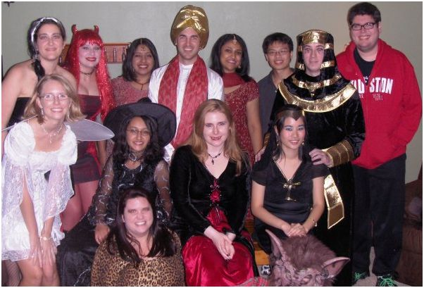

You are cordially invited to

